ID: Unique ID of the patient
Age: Patient’s age at the ICU admission
RRT: Indicator variable, = 1 if the patient received renal replacement therapy (RRT), = 0 otherwise
AKIN: Patient’s maximum AKIN* classification, which was determined before RRT initiation in patients who received RRT and during their entire ICU stay in patients who did not receive RRT
*Acute Kidney Injury Network (AKIN) classification measures the severity of acute kidney injury (AKI), from Stage 0 to 3, with 3 being the worst stage.
SOFA: Patient’s worst SOFA^ score during the ICU stay
^Sequential organ failure assessment (SOFA) score is used to track a person's status during the stay in the ICU to determine the extent of a person's organ function or rate of failure. It is a number between 0 and 24 with 24 representing the worst condition.
Mortality: Indicator variable, = 1 if the patient died in the hospital, = 0 otherwise

RIFLE and AKIN Score:
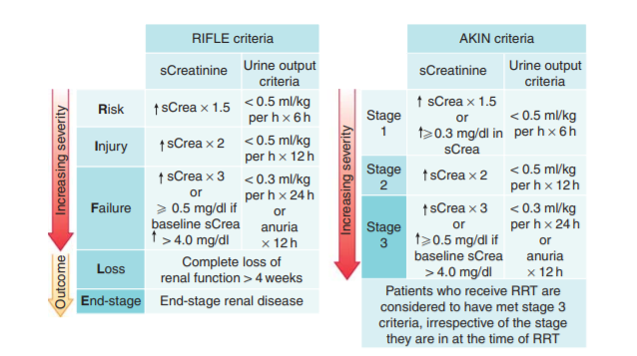

https://www.precisepk.com/blogs/what-is-acute-kidney-injury-aki
SOFA Score:
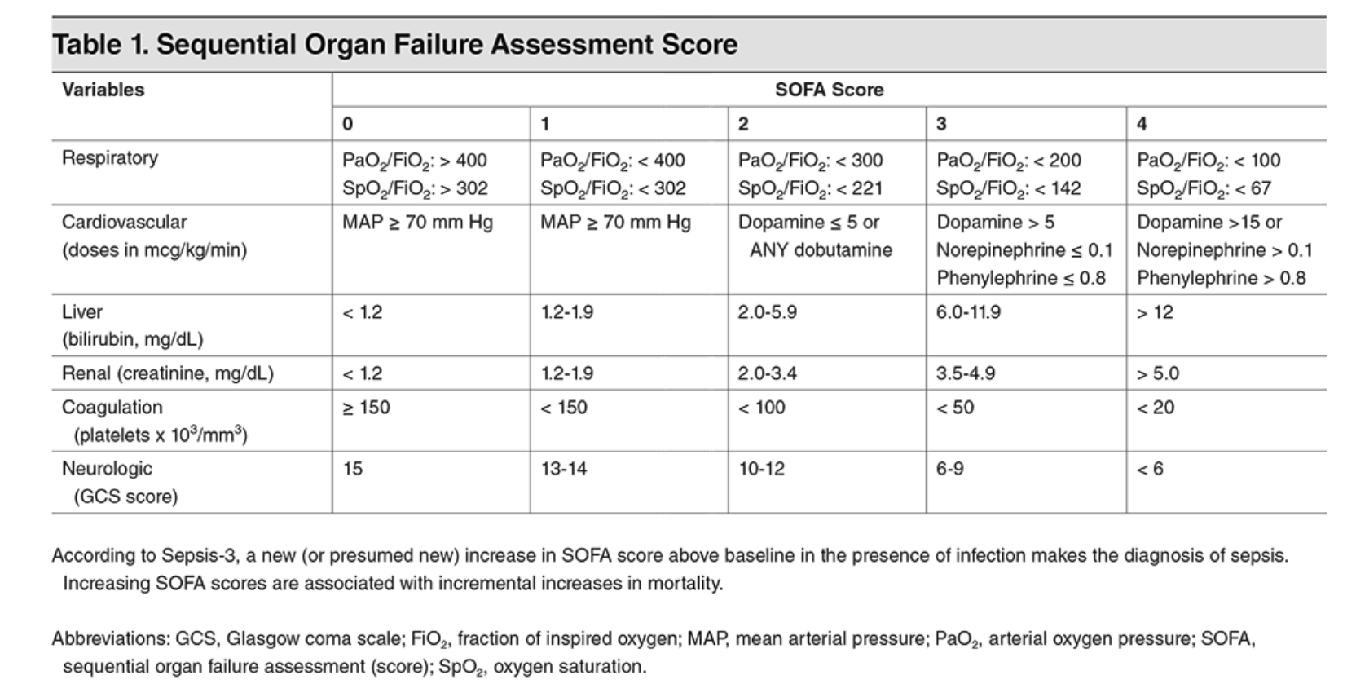
https://www.ebmedicine.net/topics/infectious-disease/sepsis-septic-shock

